React js features::  
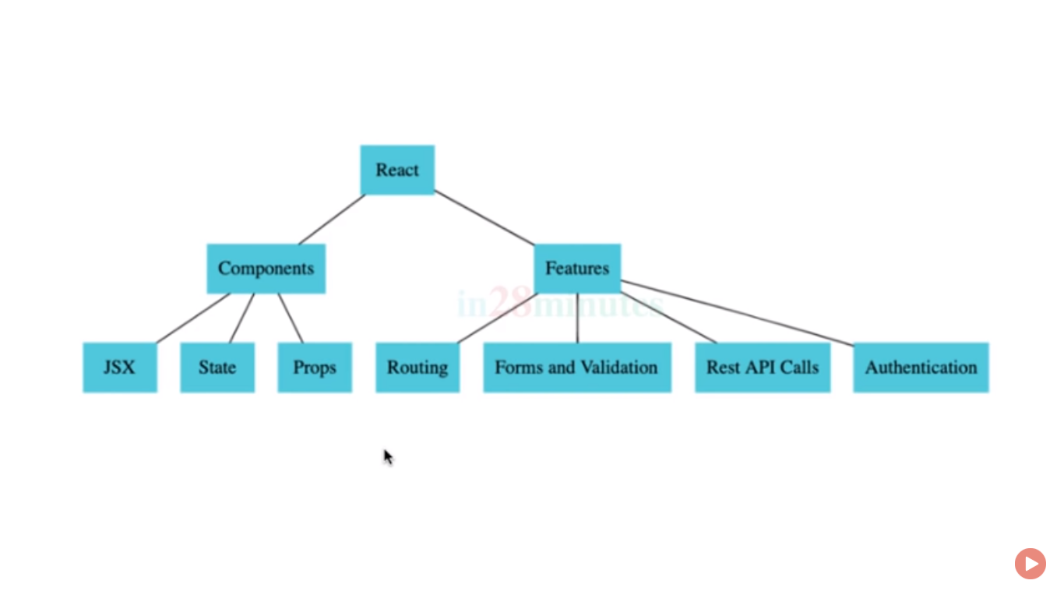

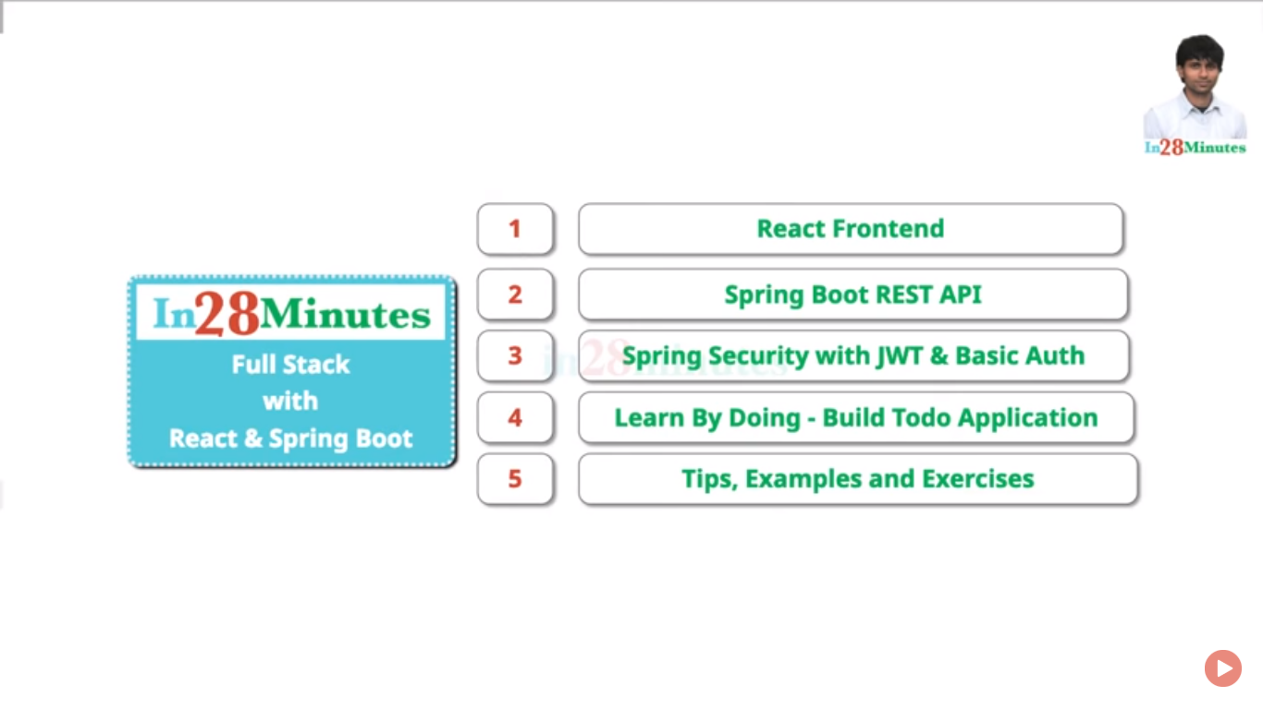

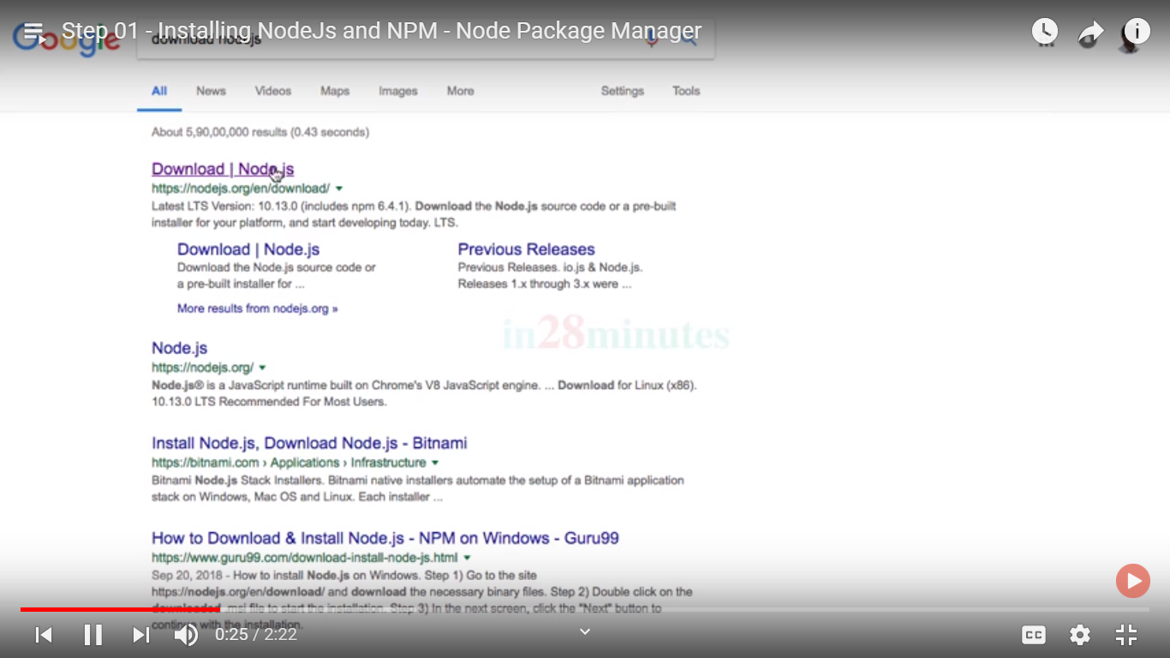

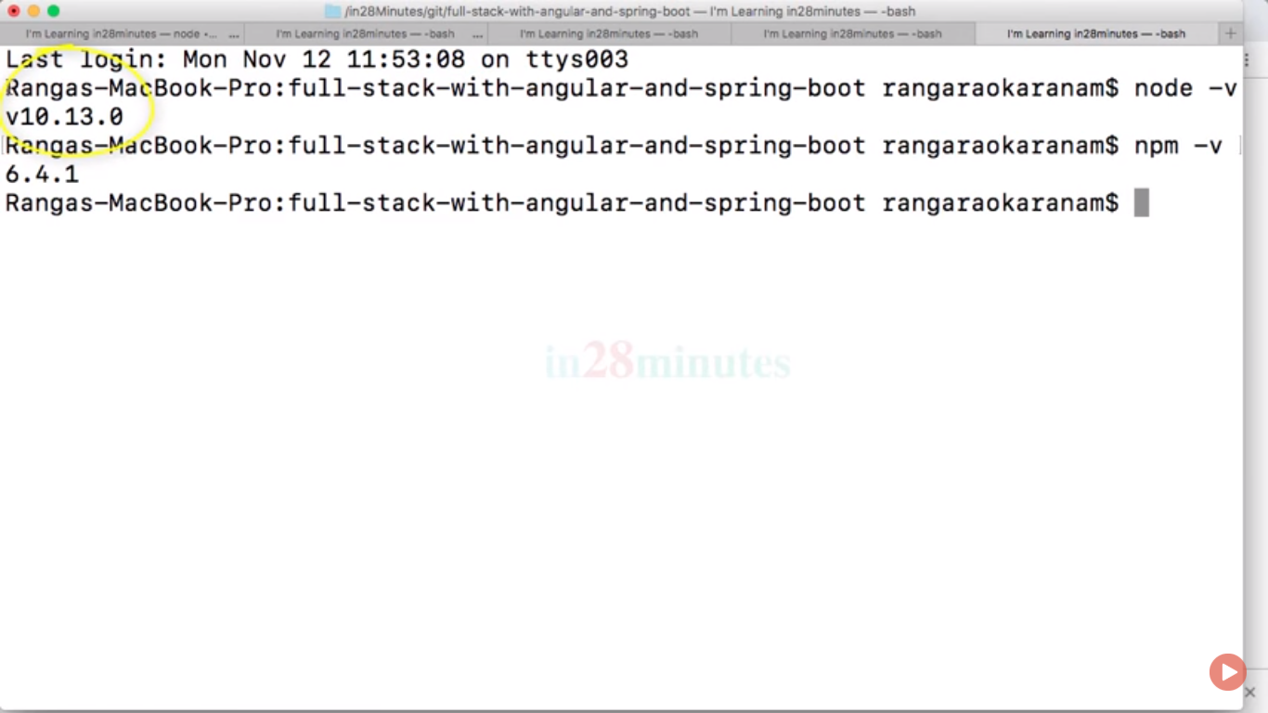

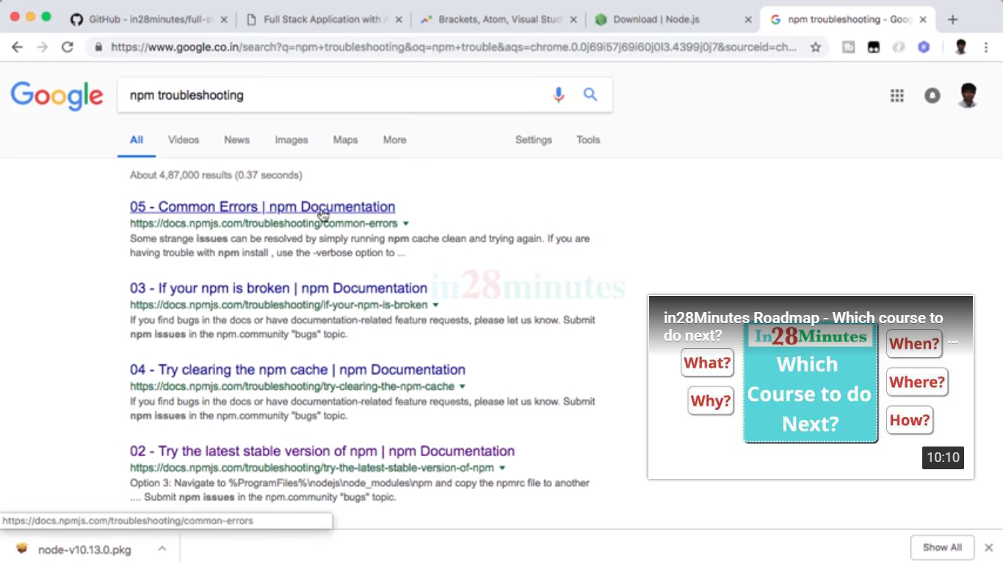

Repository mgt like gradle and maven::

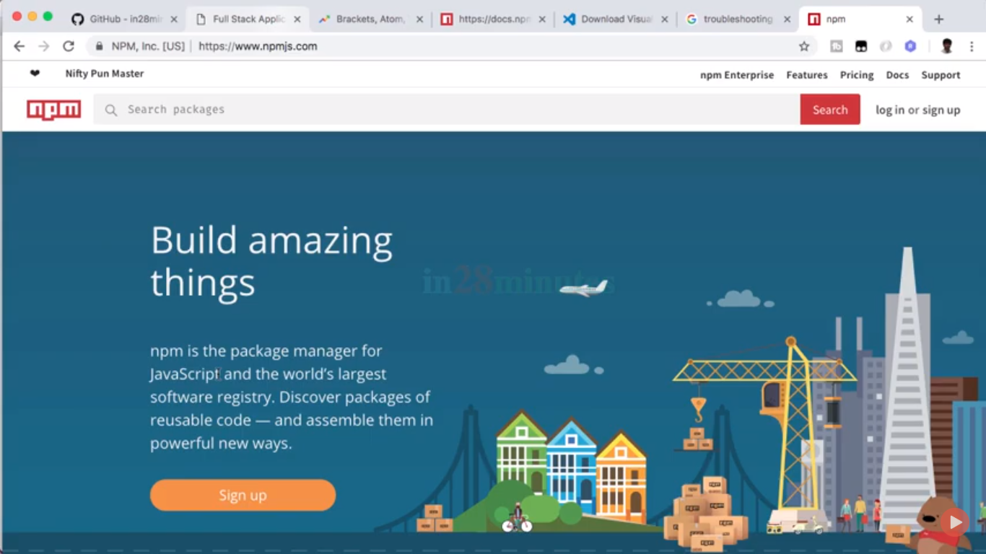

First project creation ::

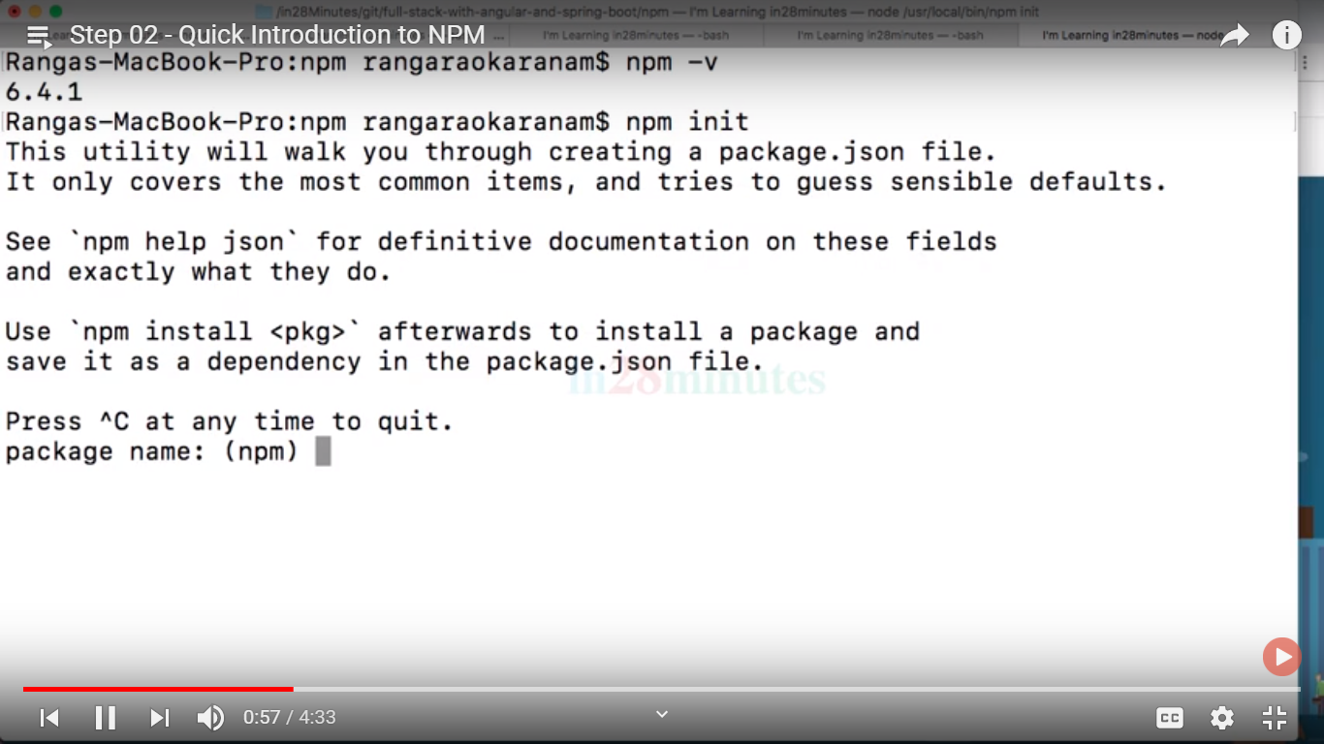

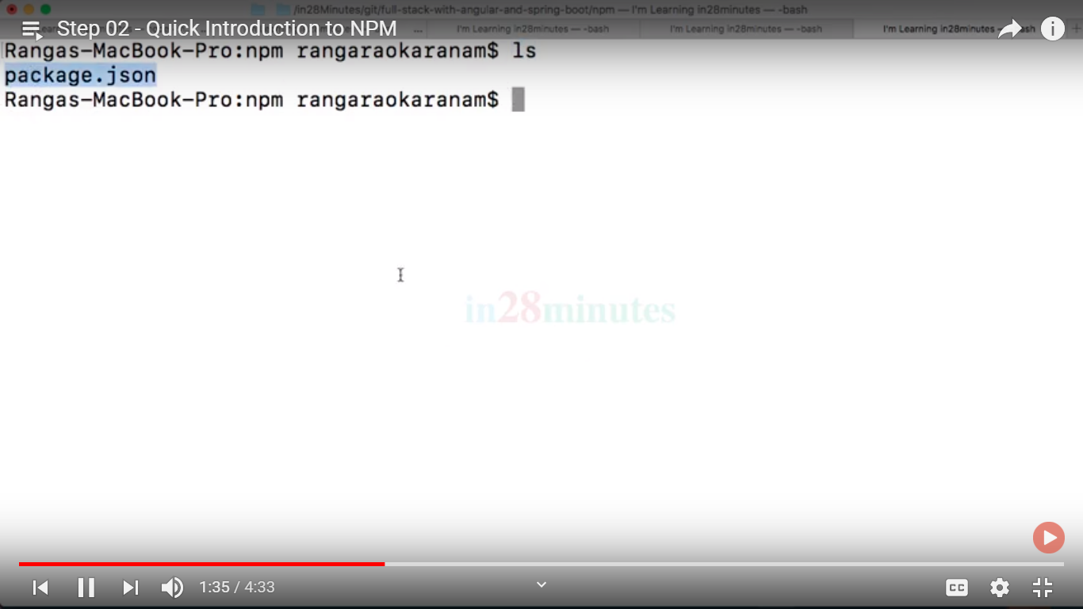

Package.json data

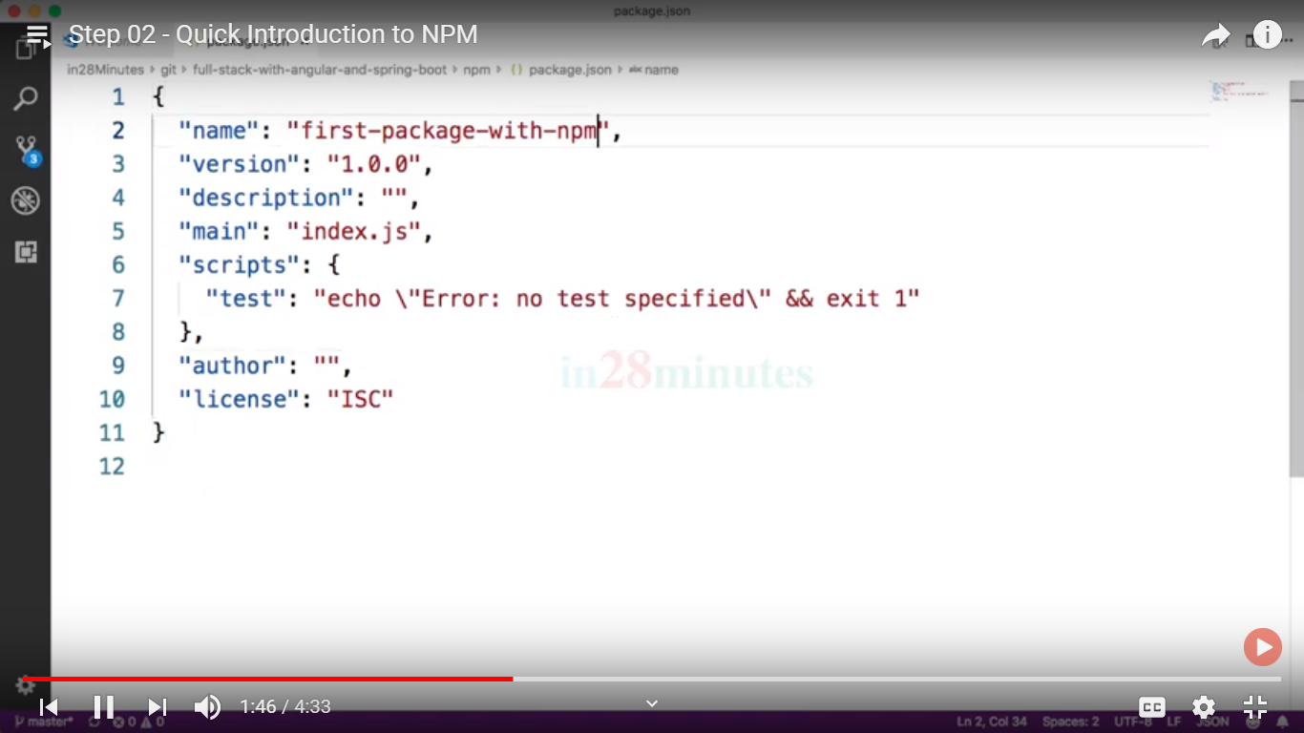

If I want to download jquery file then use::  
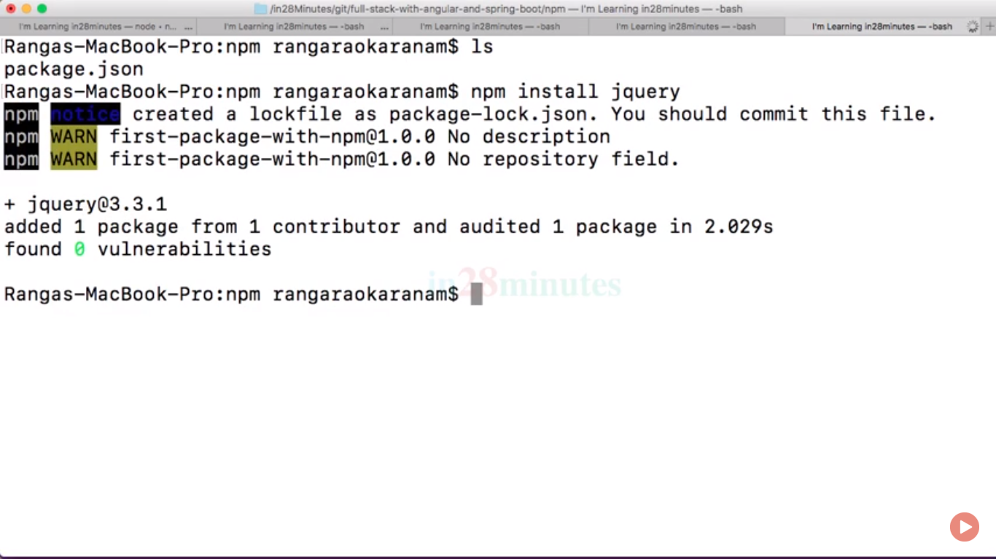

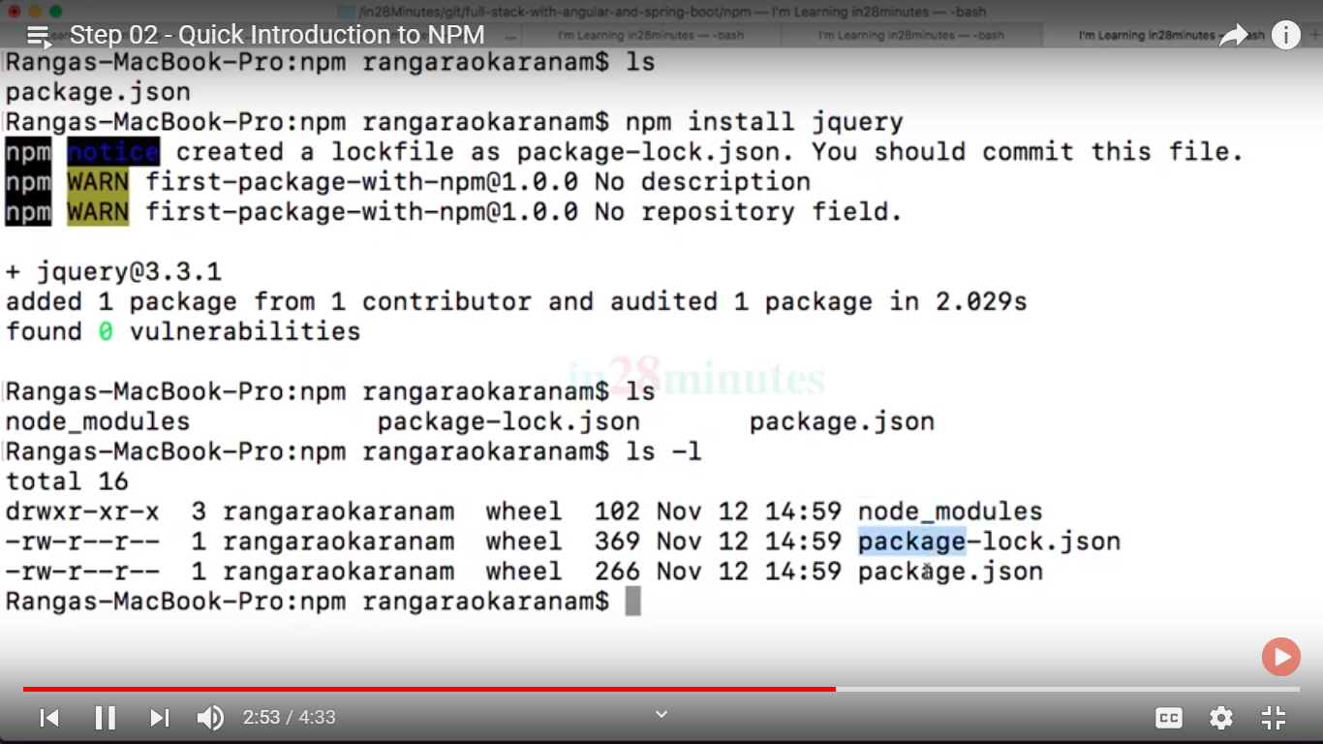

Now package.json change:: where it has version with carrete ^ which   
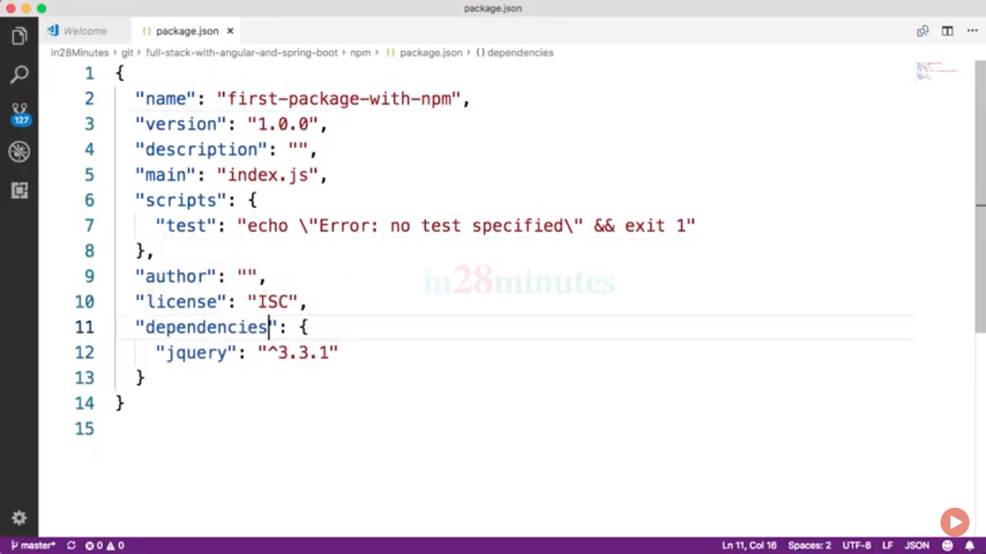

If we used npm install command all dependency are downloaded inside node_module in same package:



Now package.json change:: where it has version with carrete ^ which   


If we used npm install command all dependency are downloaded inside node_module in same package:

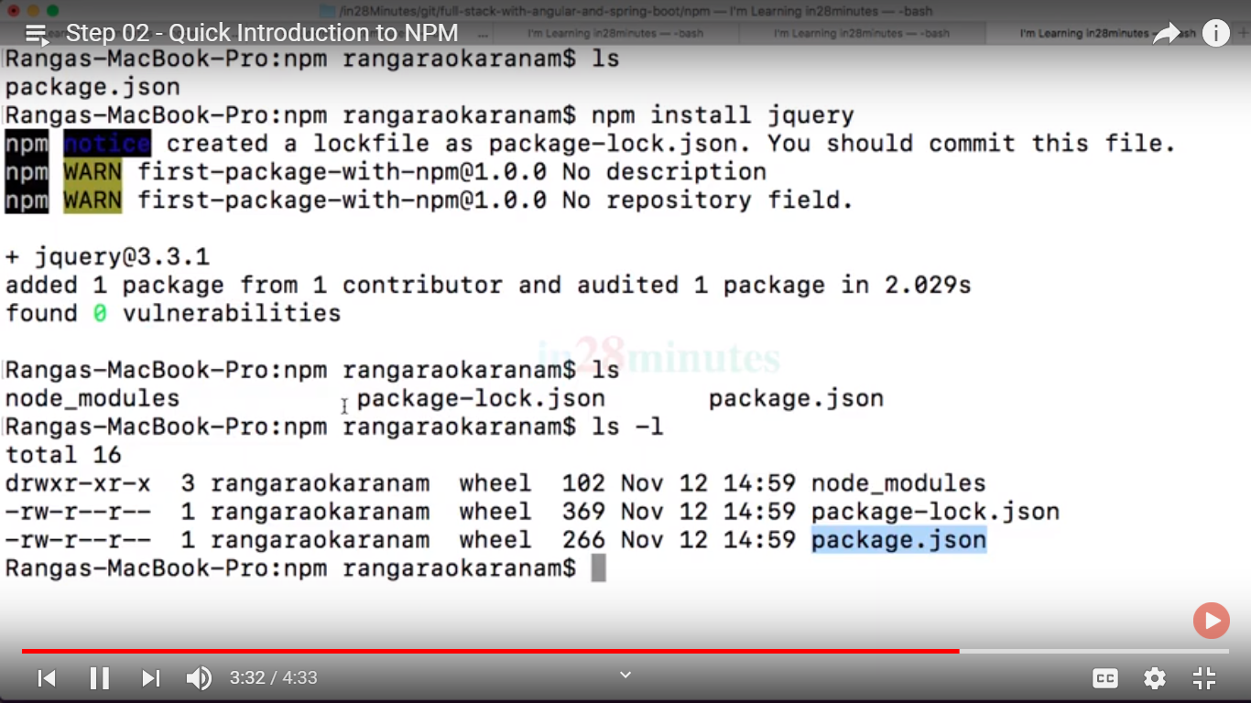

Npm install command download all dependencies when another developer not having node_module package on same.

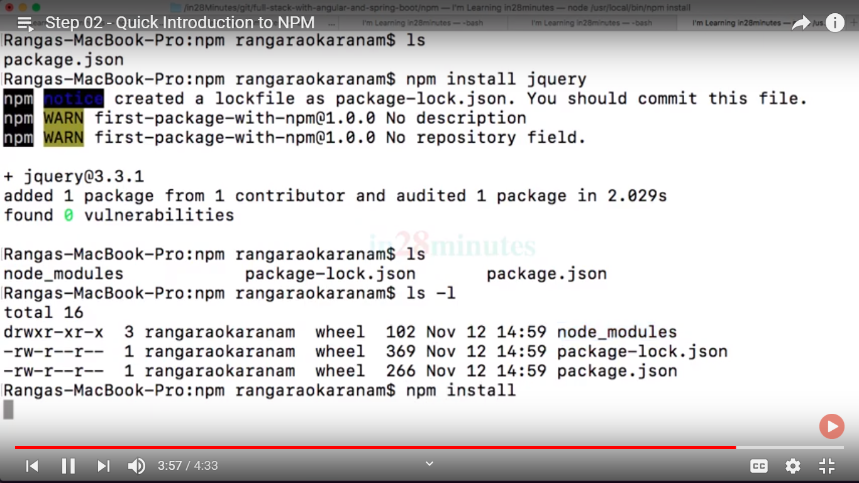

Now visual studio code editor setup::

For trouble shoting visual studio code editors::  
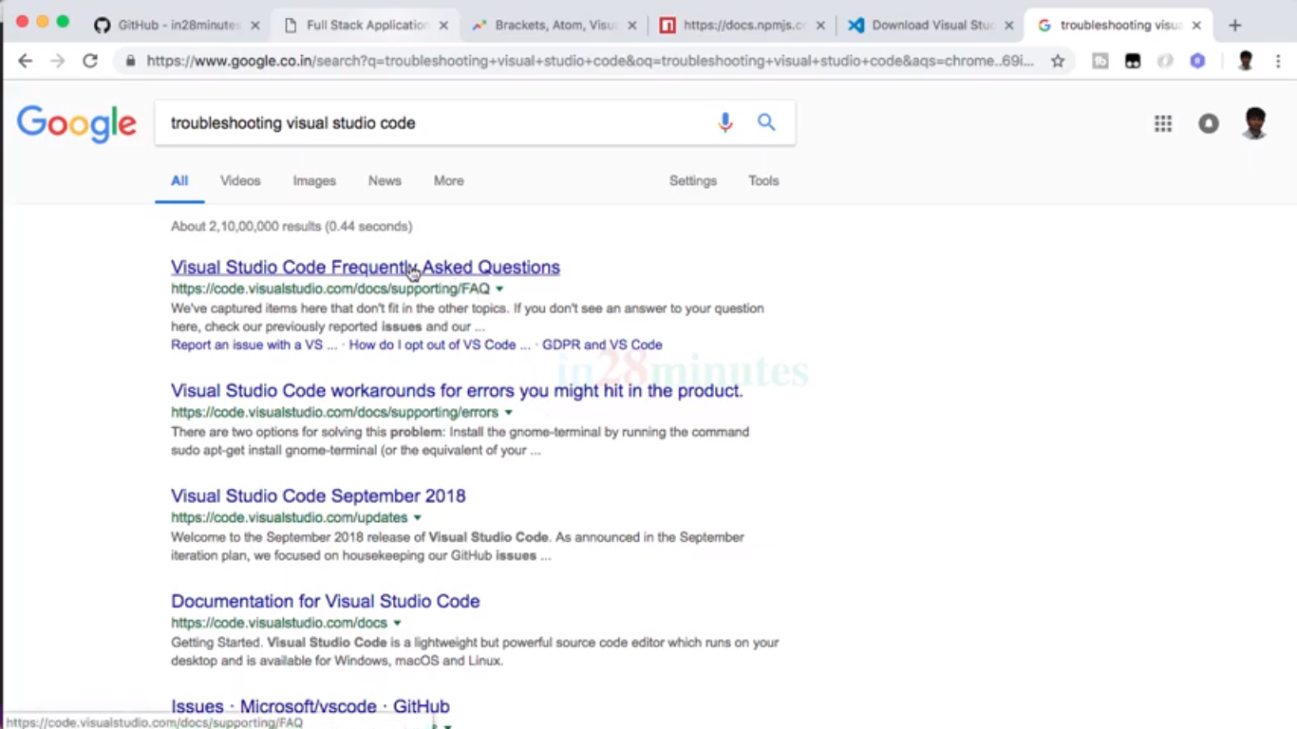

Architecture of react js::  
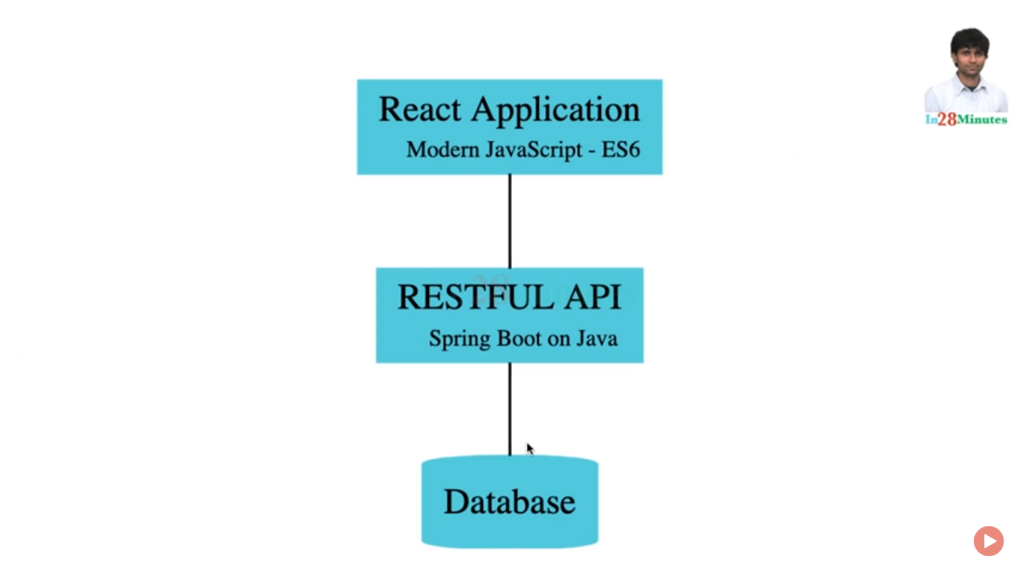

For flexible architecture:: you needs to used different front and backend apps;

Create react app::  
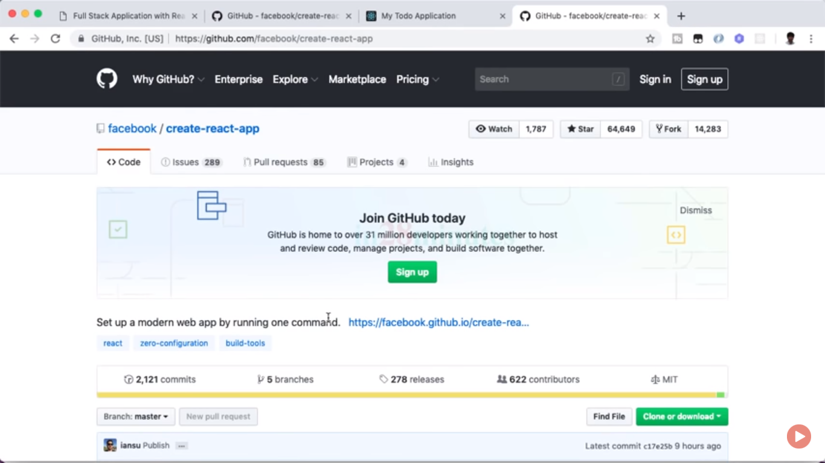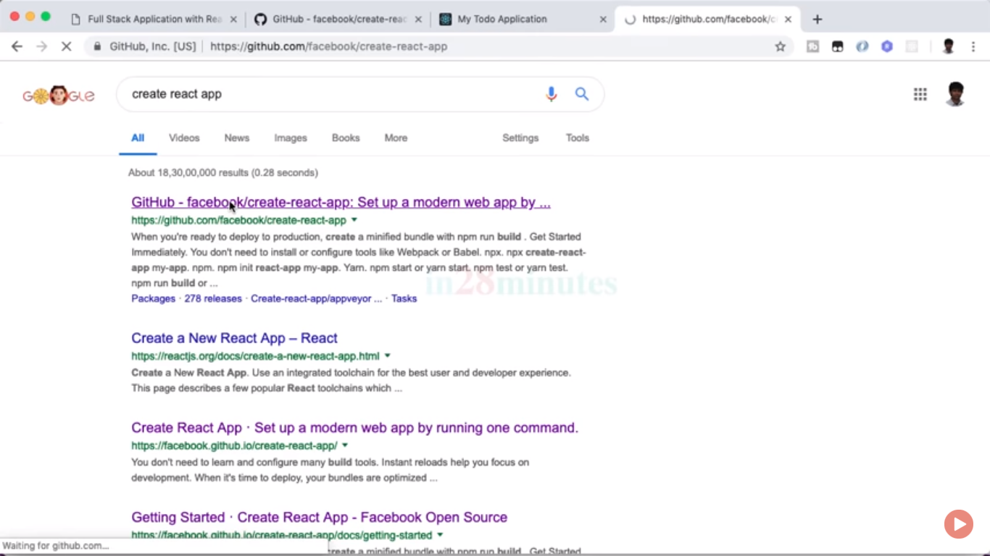

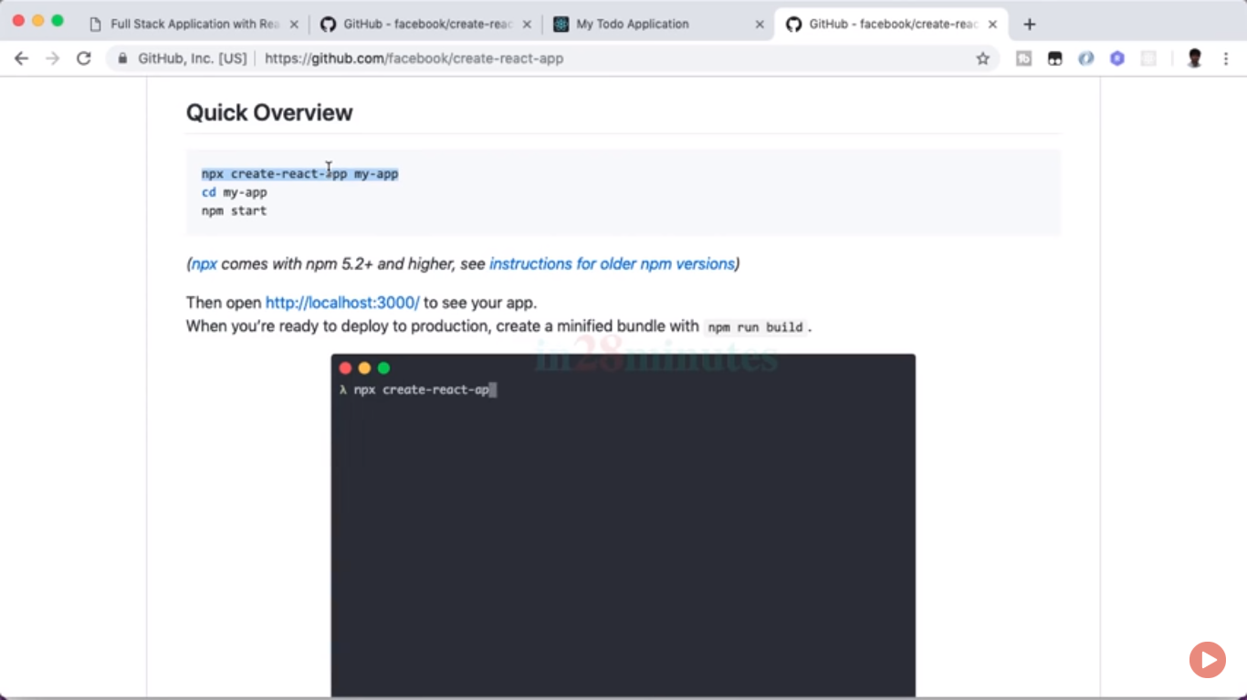

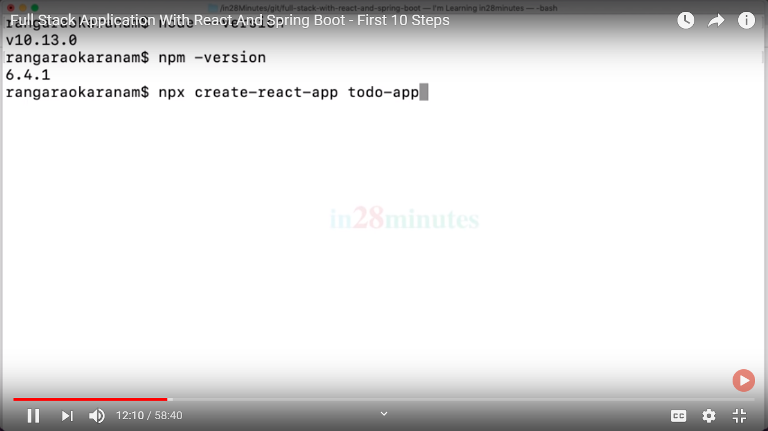

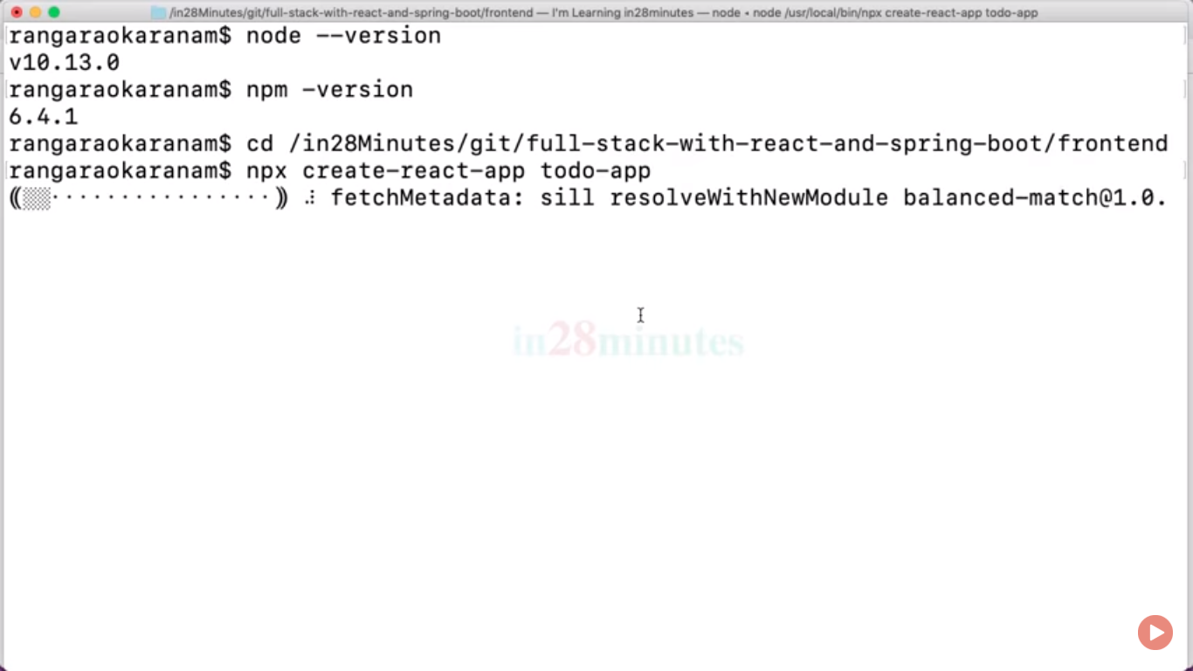

If any problem in npx

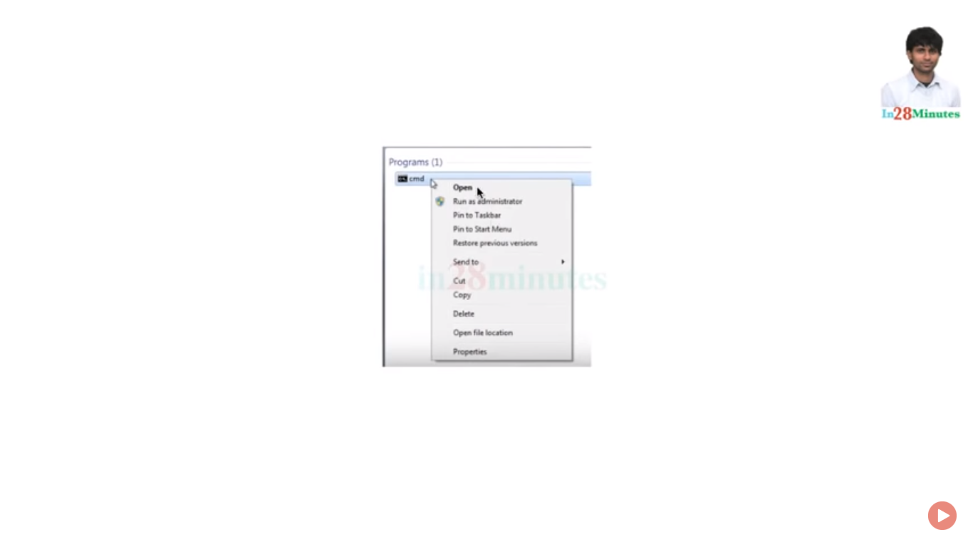

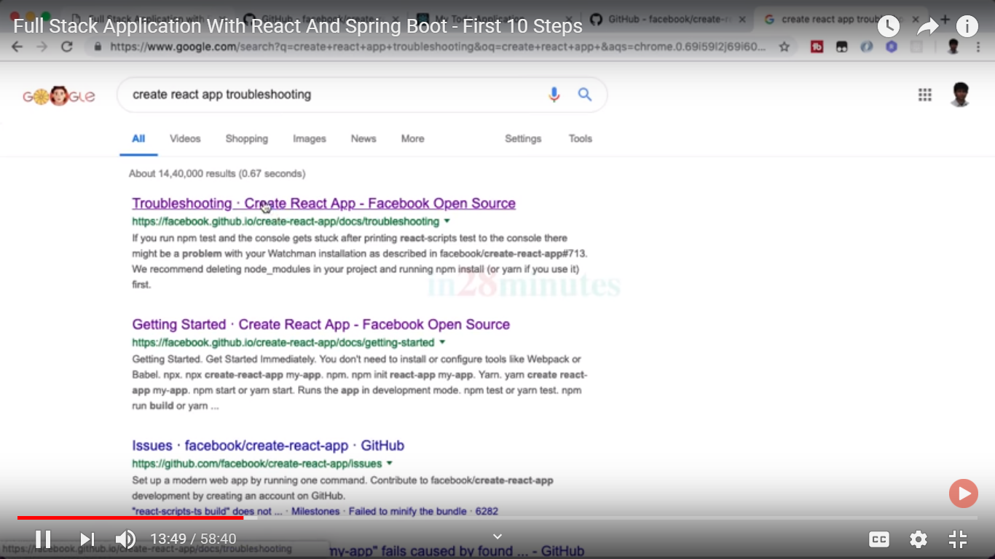

For npm commands::  
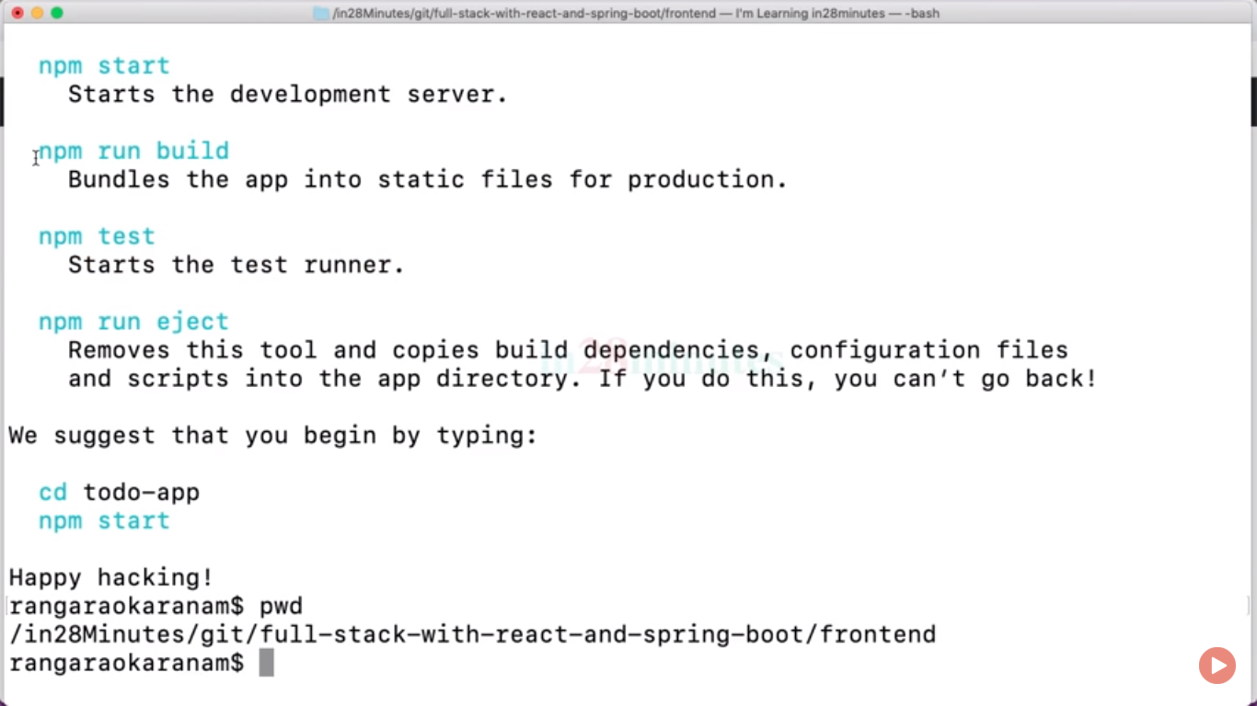

Npm run build ::compressed all js files in one.

For launching an app used npm start

App.js file contain first page::

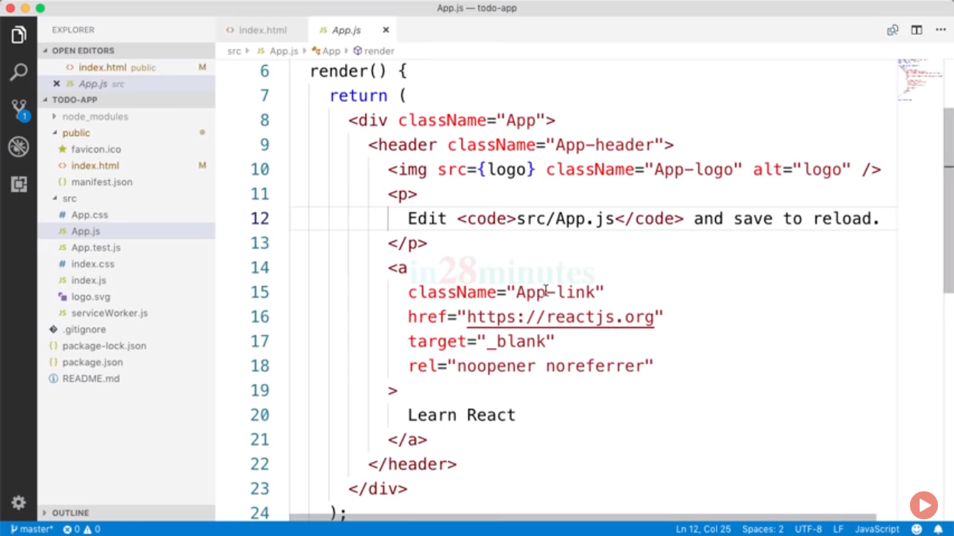

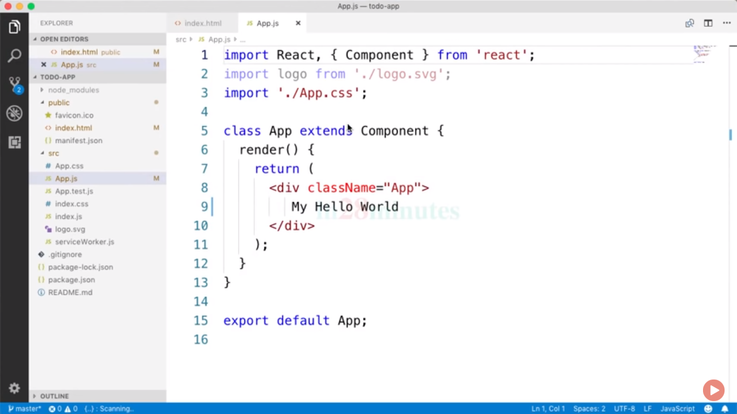

Checking individual folder and files in project::  
package.json same as pom.xml

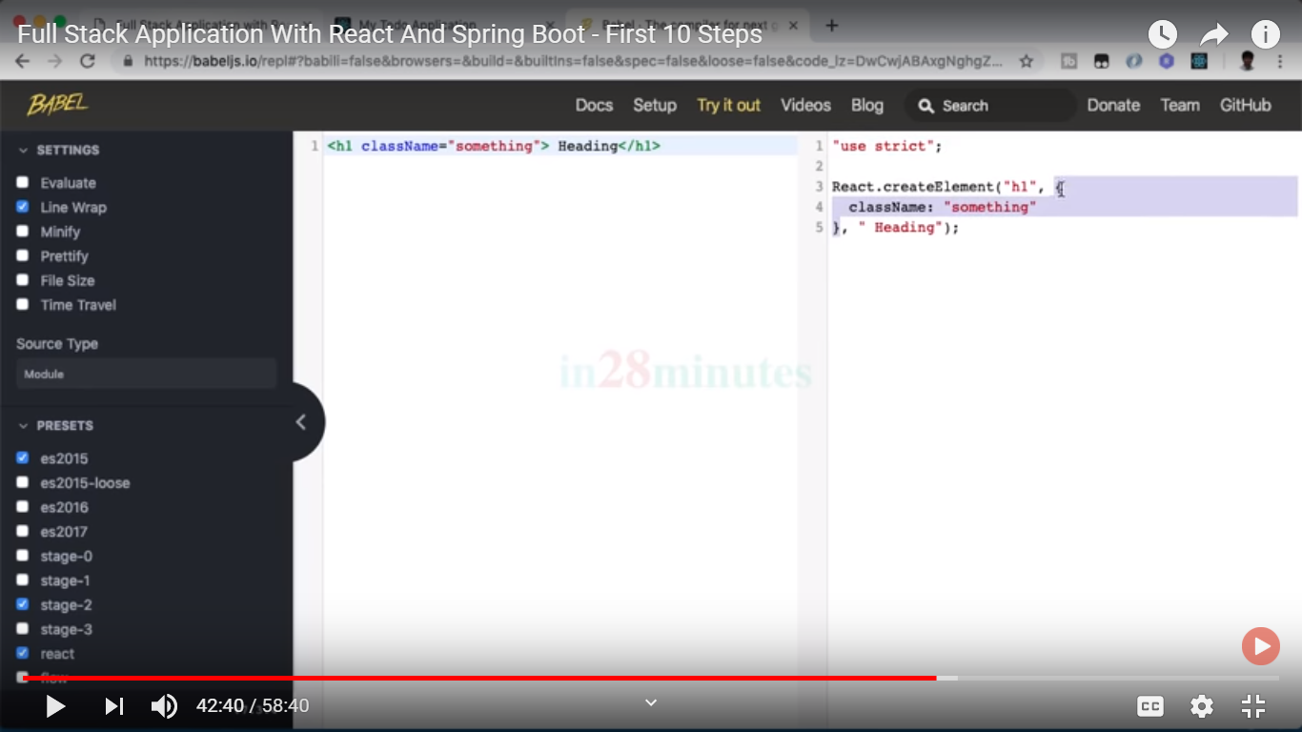  
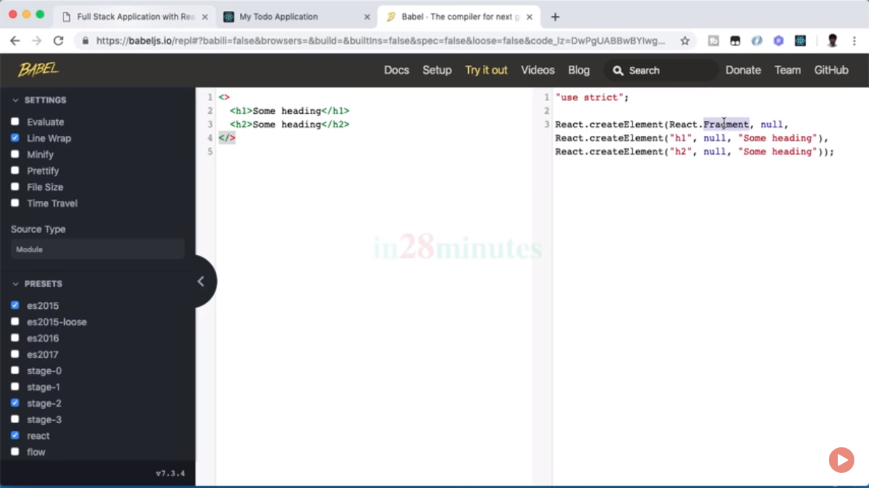

Now having project sturture change where learning-exmple inside componets and app.js has no componets FirestComponent.js then needs to import that file in it.

Import FirstComponent from ‘./components/learning-examples/FirstComponent’

Now having error::

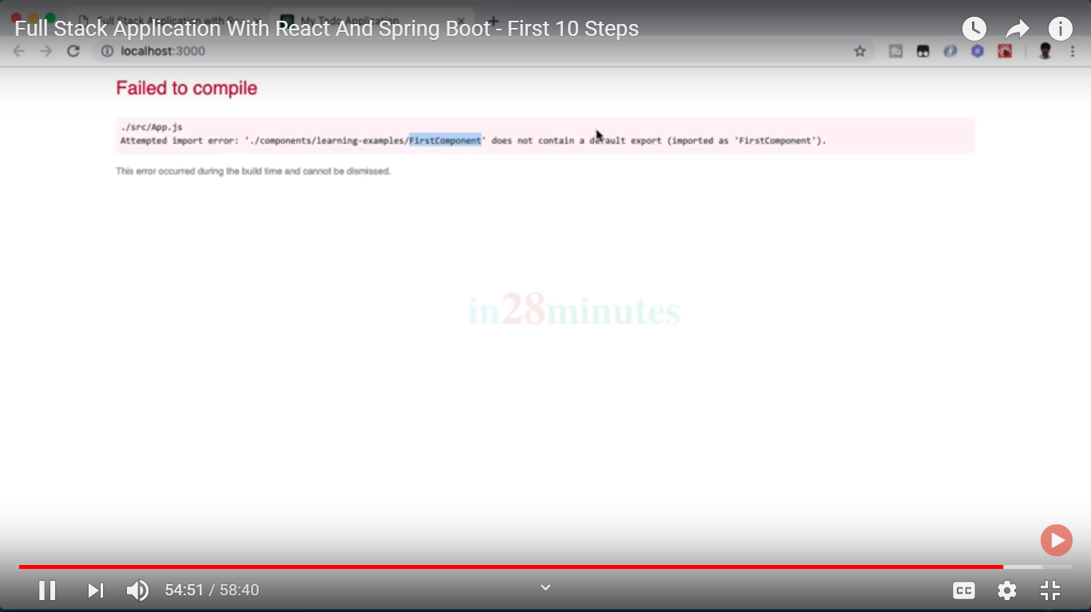

Does not contains default export::

If we want that your component should be used by another model component then you needs to define class with export default in its accessifier.. also needs to be import React PACKAGE.

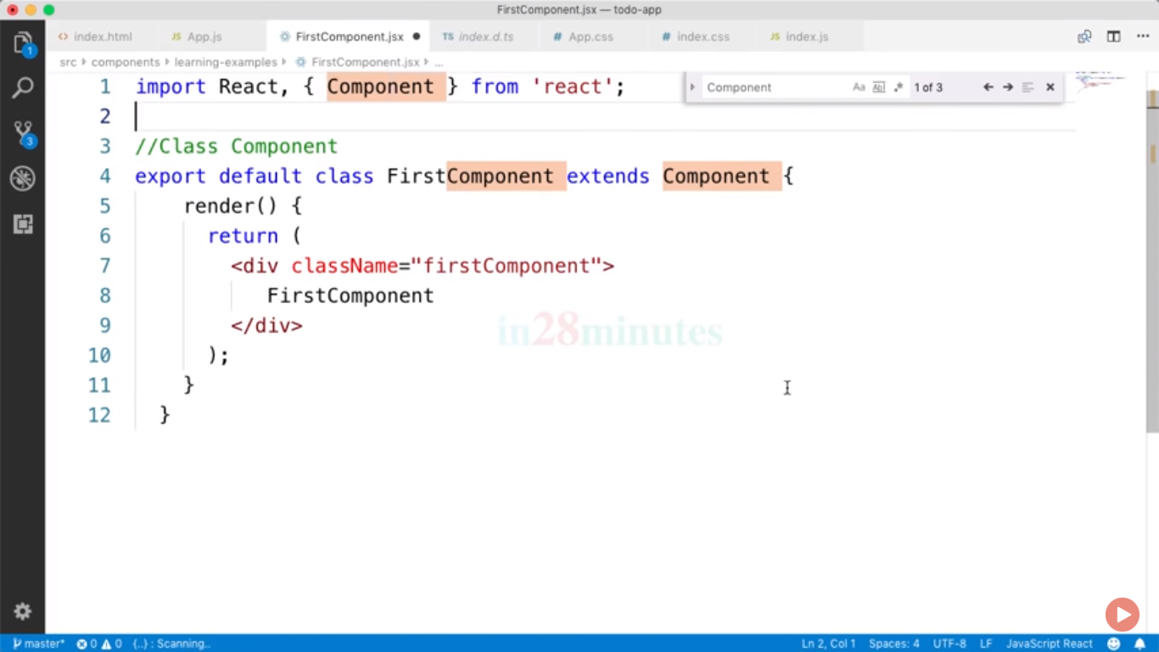

First component is always default export if u want multiple component to be added into main AppComponets then you must be added like>>like import FirstComponsent,{SecondComponset}

